Mockups for Guru99 Bank
Login Page
This page will be used for login by Manager as well as Customer
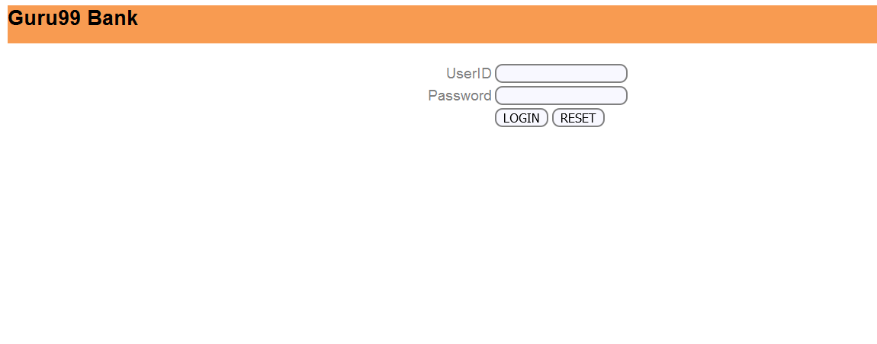
Home Page
Manager
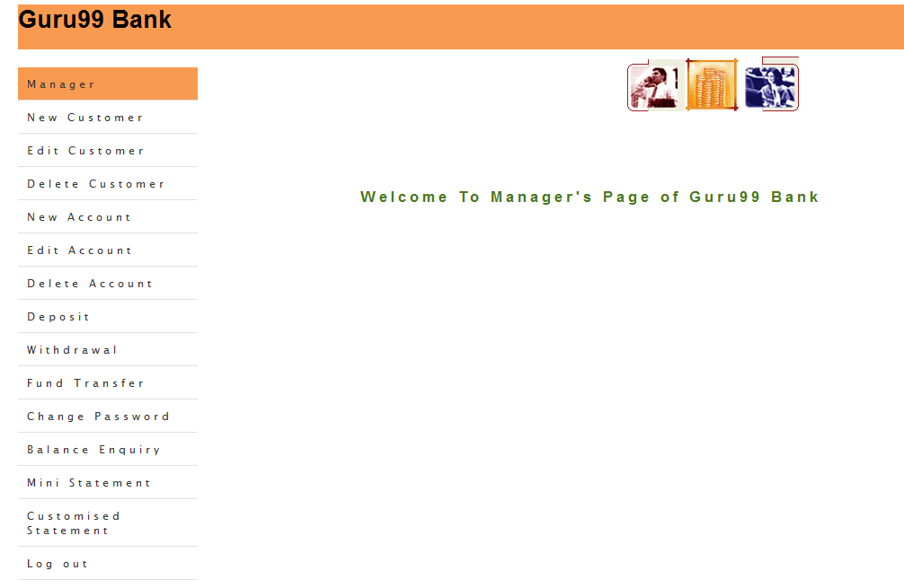

Customer
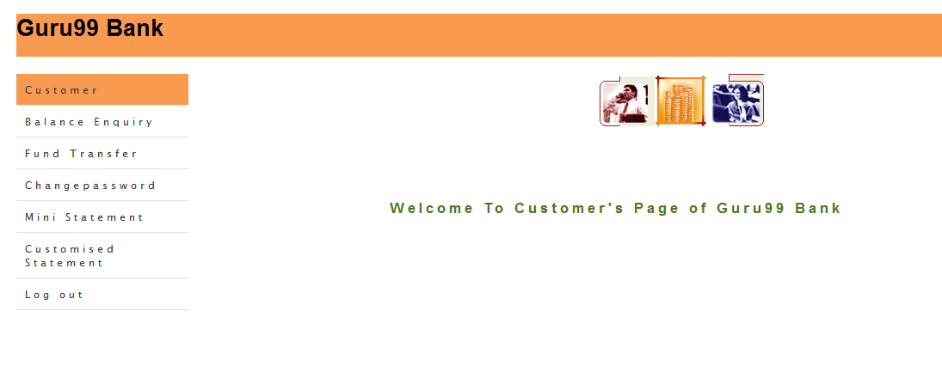
Add Customer Functionality for Manager
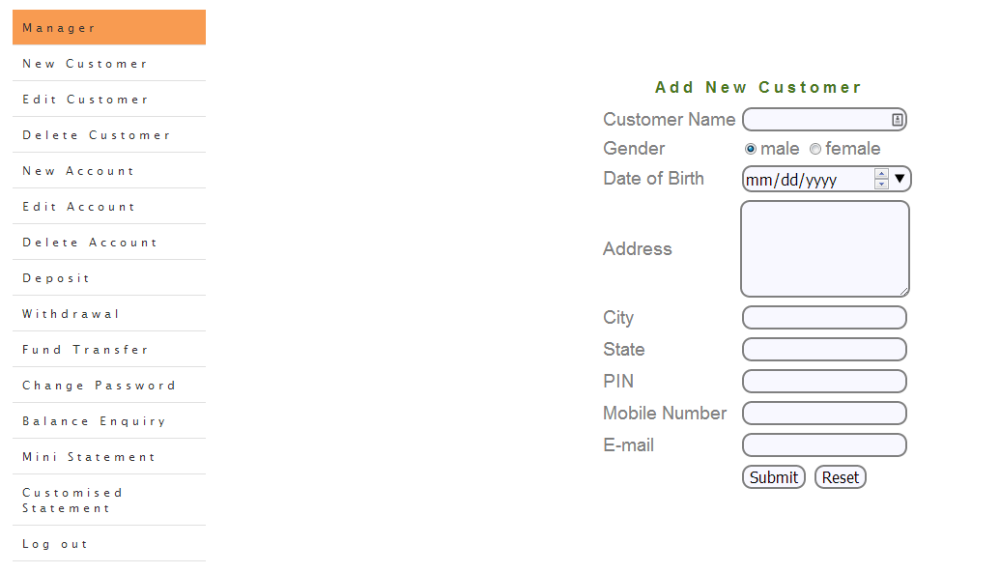
Add Account Functionality for Manager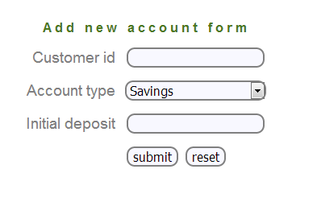
Mini Statement Functionality for Manager/Customer

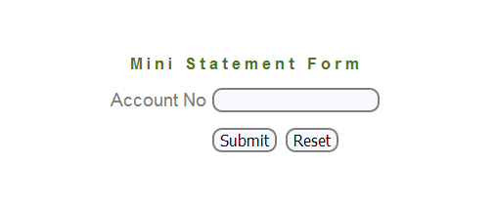
Customized Statement for Manager/Customer
